**BUILDING A FACE DETECTION APP ON AWS**

**NAME: NEELA SAIRAM MOBILE: 9603757363**

**EMAIL:** [**sairam.neela07@gmail.com**](mailto:sairam.neela07@gmail.com)

**OBJECTIVE:**

The main objective of building this face detection application is to detect the image and describe about the image using the AWS.

**DESCRIPTION:**

To detect the image, we use four components I.e., Telegram Bot, EC2, S3 and Amazon Rekognition. When the image is uploaded to the telegram, that image will be taken by the EC2 and will try to store that image into a bucket which is created. EC2 will also send that respective image to the Amazon Rekognition to detect the image, and the description of that image will be sent back as a response to the EC2 and ultimately to the Telegram Bot.

**SCREENSHOTS:**

**AWS**:

1. **AWS Login screen with Username:**

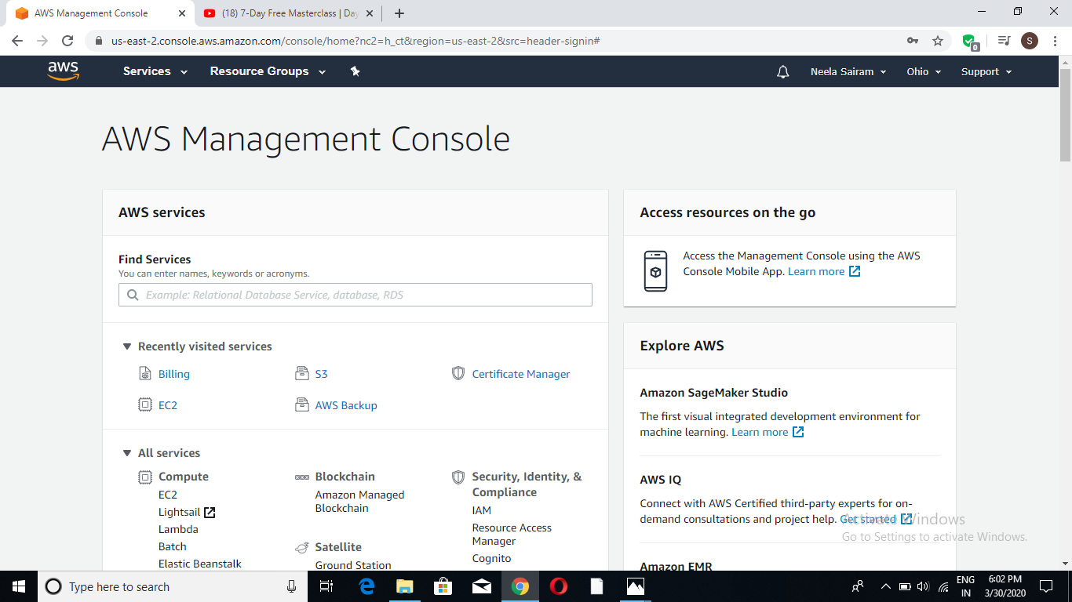

1. **EC2 Dashboard:**

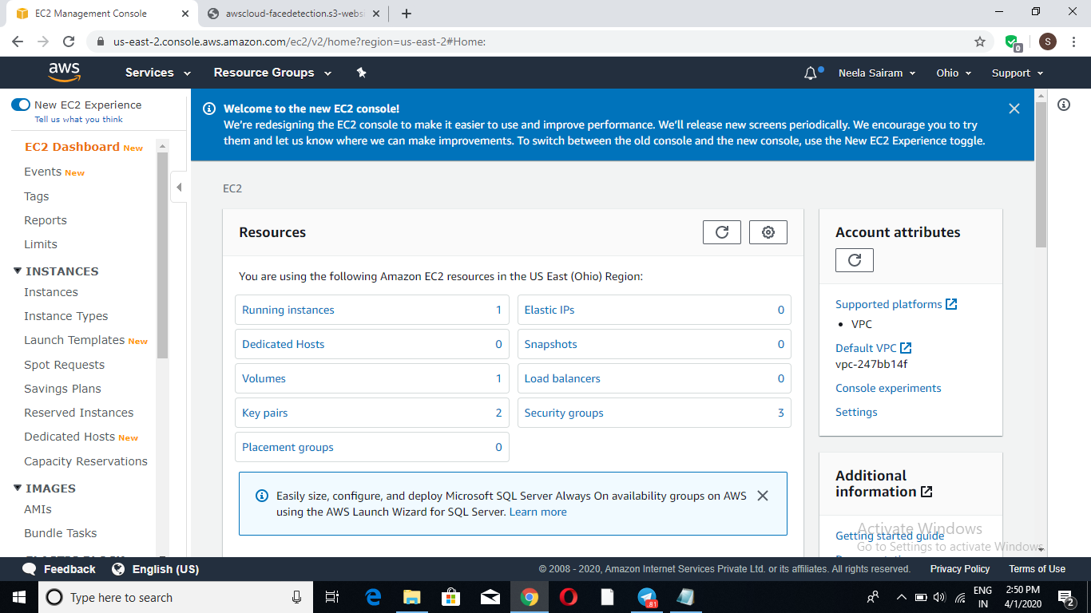

1. **S3 Dashboard:**

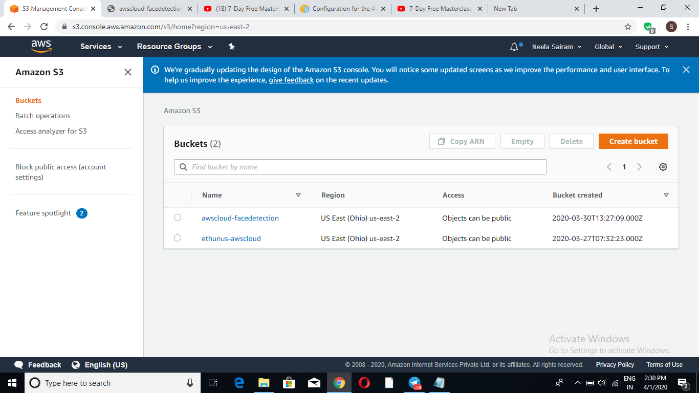

1. **Rekognition Dashboard:**

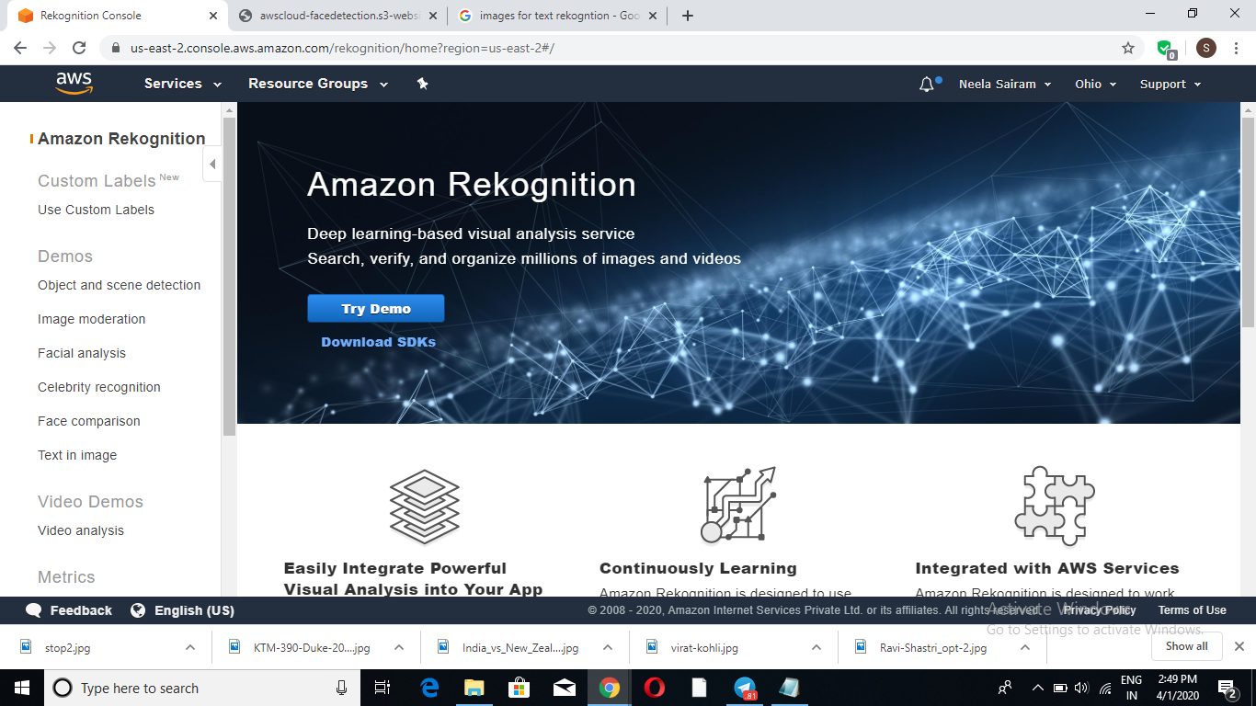

**EC2:**

1. **Choosiing an AMI:**

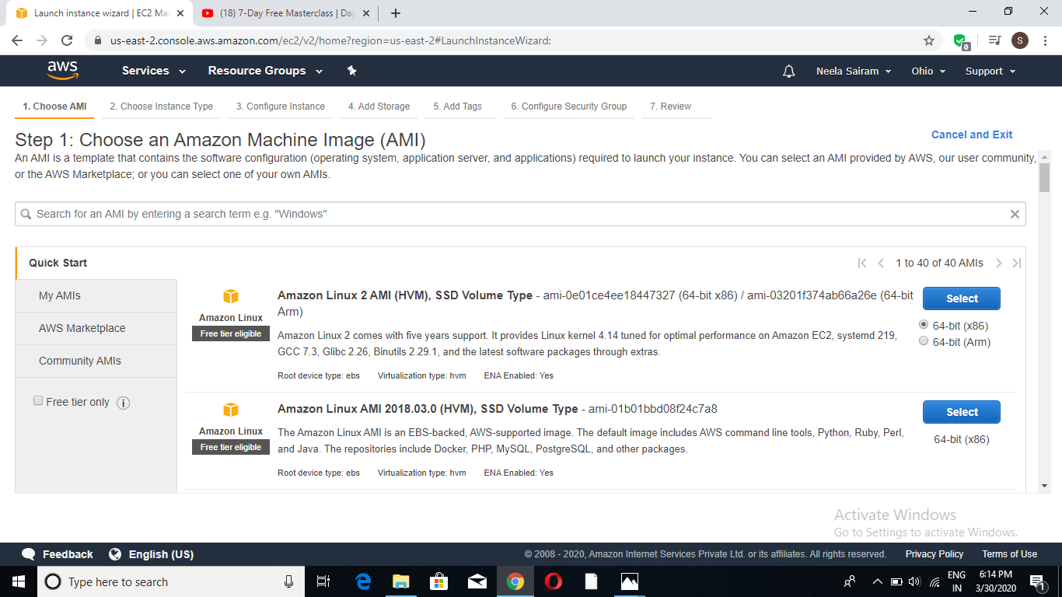

1. **Choosing an Instance Type:**

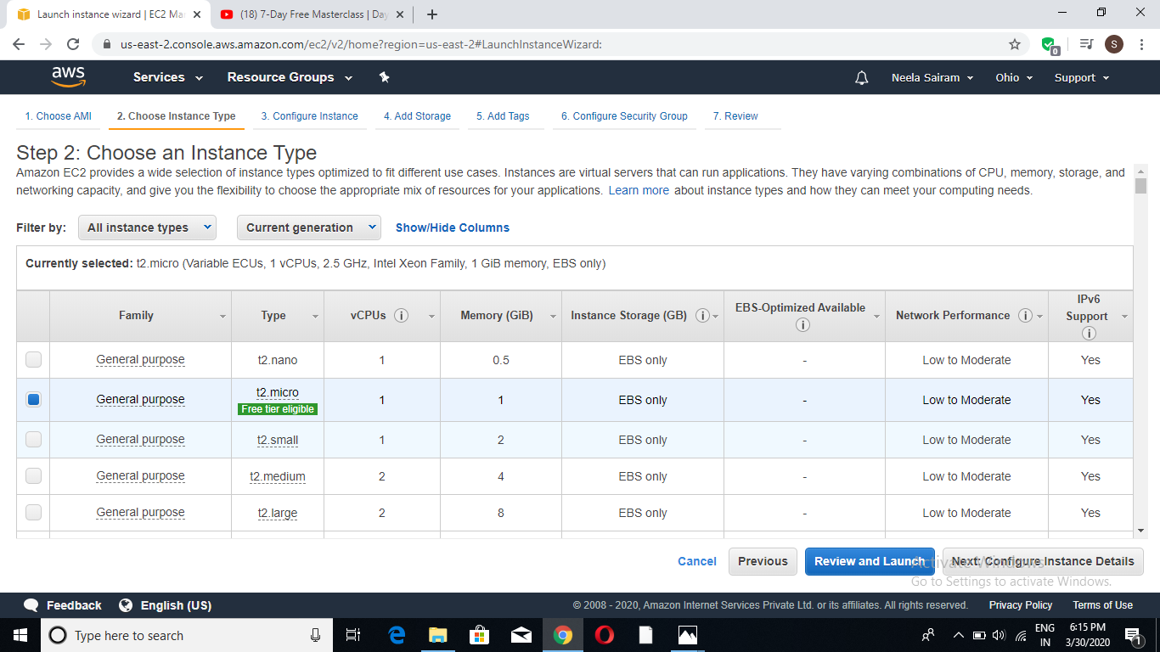

1. **Adding Storage:**

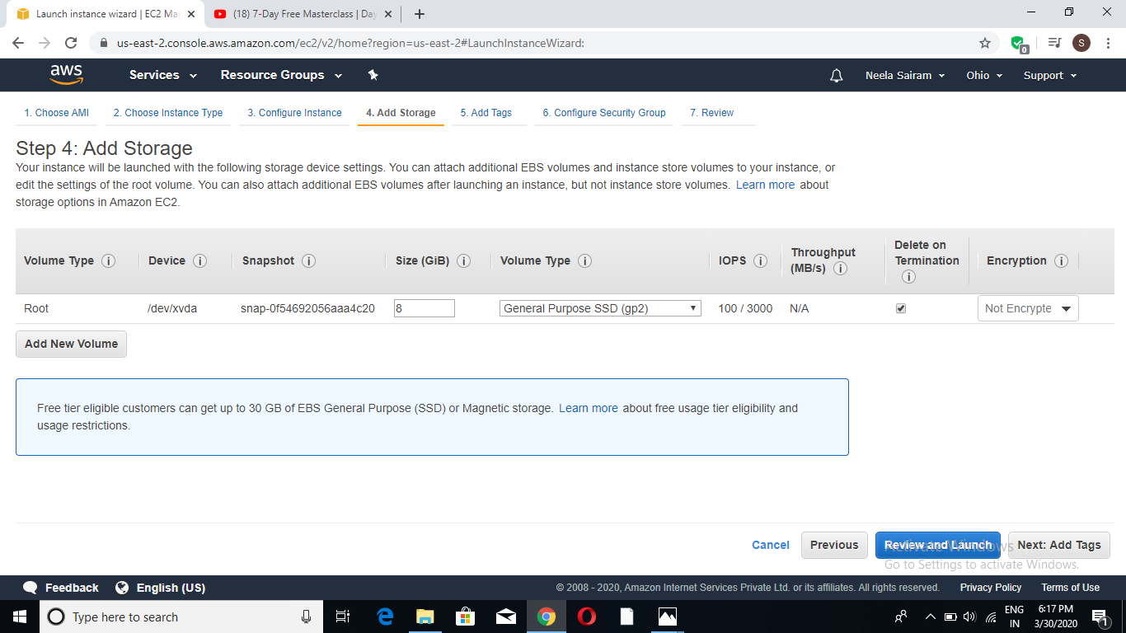

1. **Configuring Security Group:**

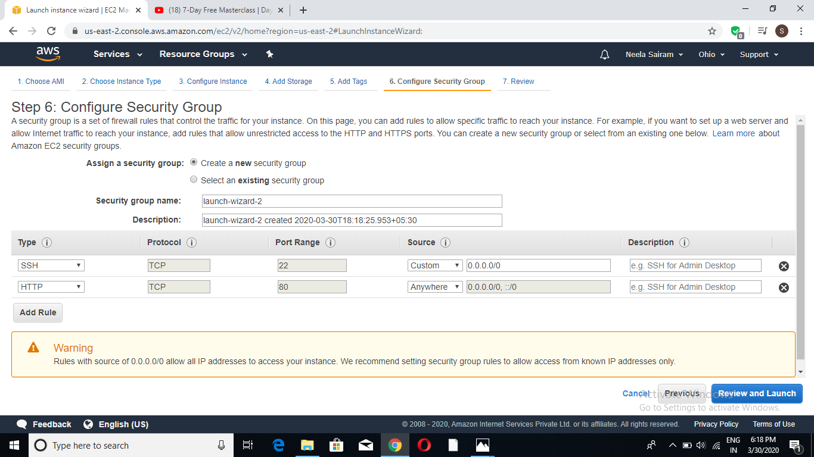

1. **Key Pair Download:**

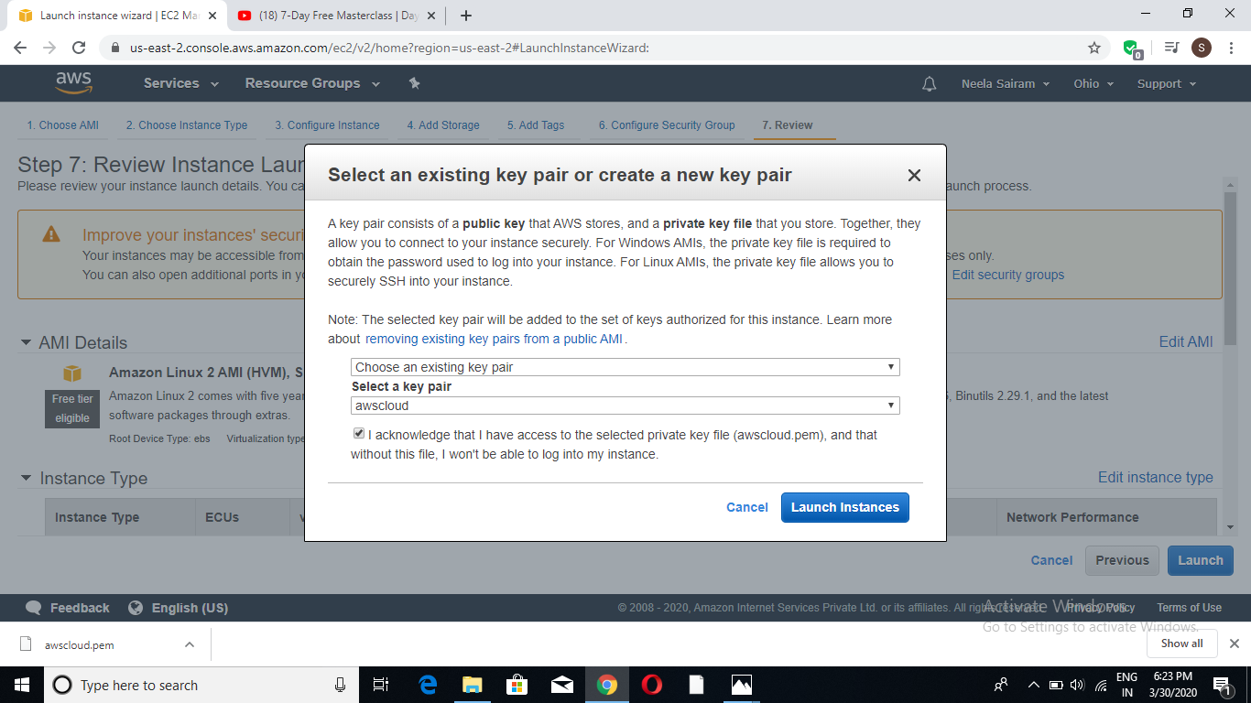

1. **PuTTYgen conversion from pem to ppk:**

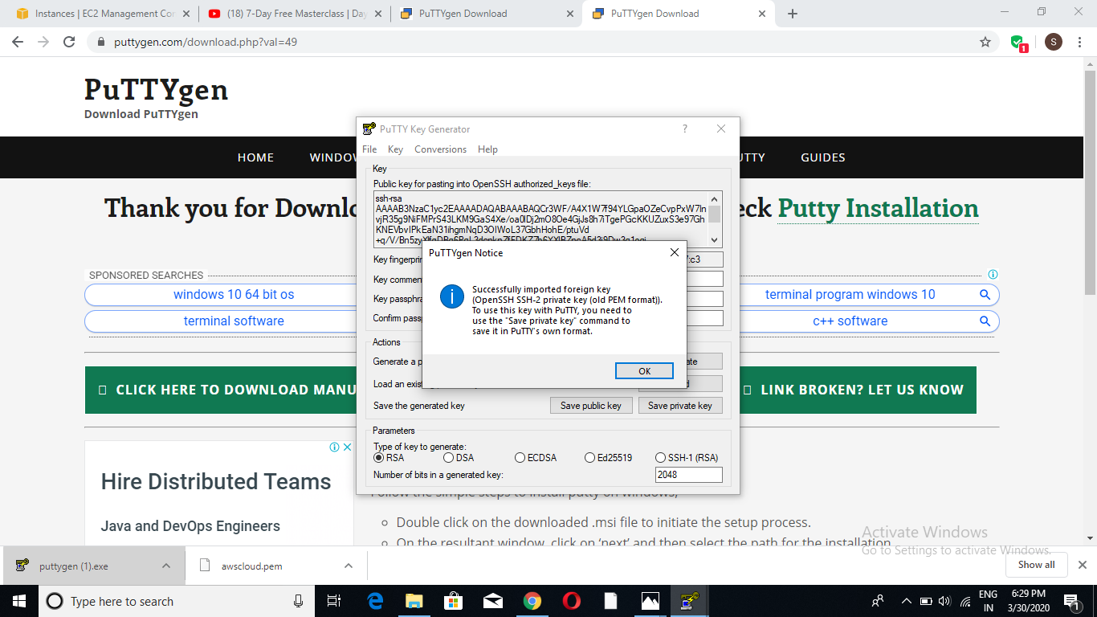

1. **Logged in EC2 black screen:**

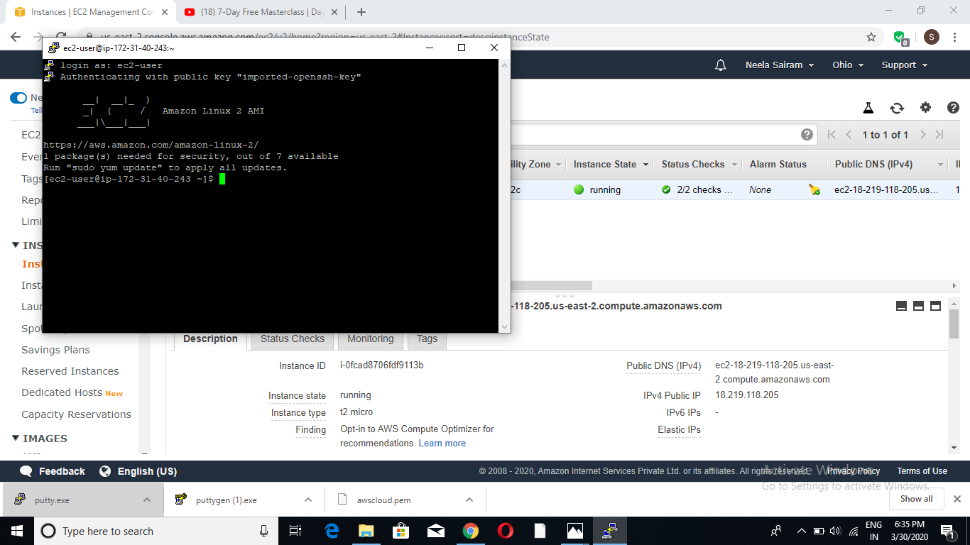

**S3:**

1. **Creating a Bucket:**

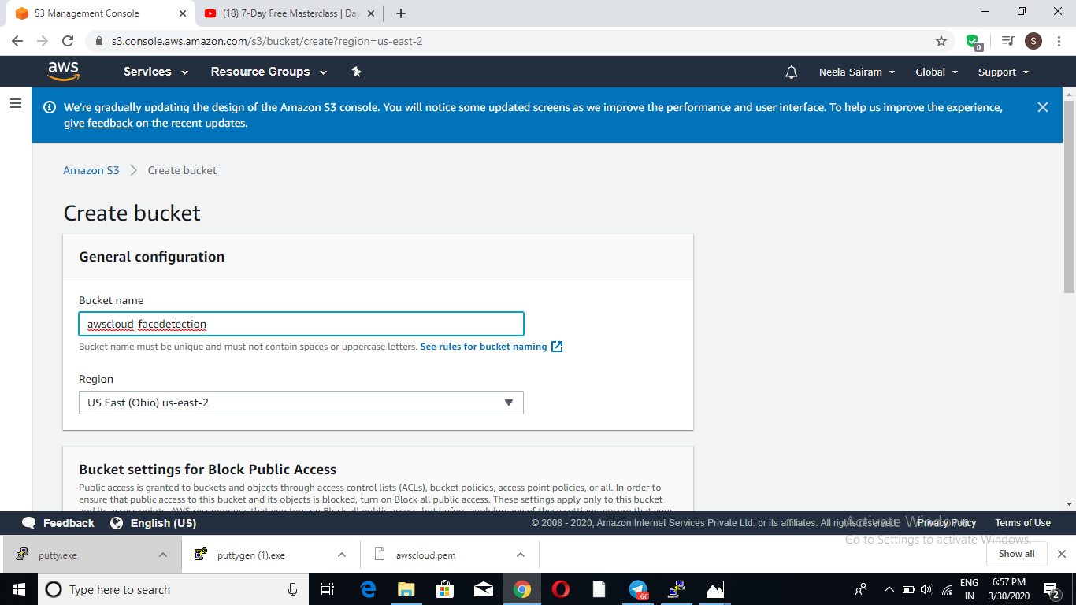

1. **Uploading an Object:**

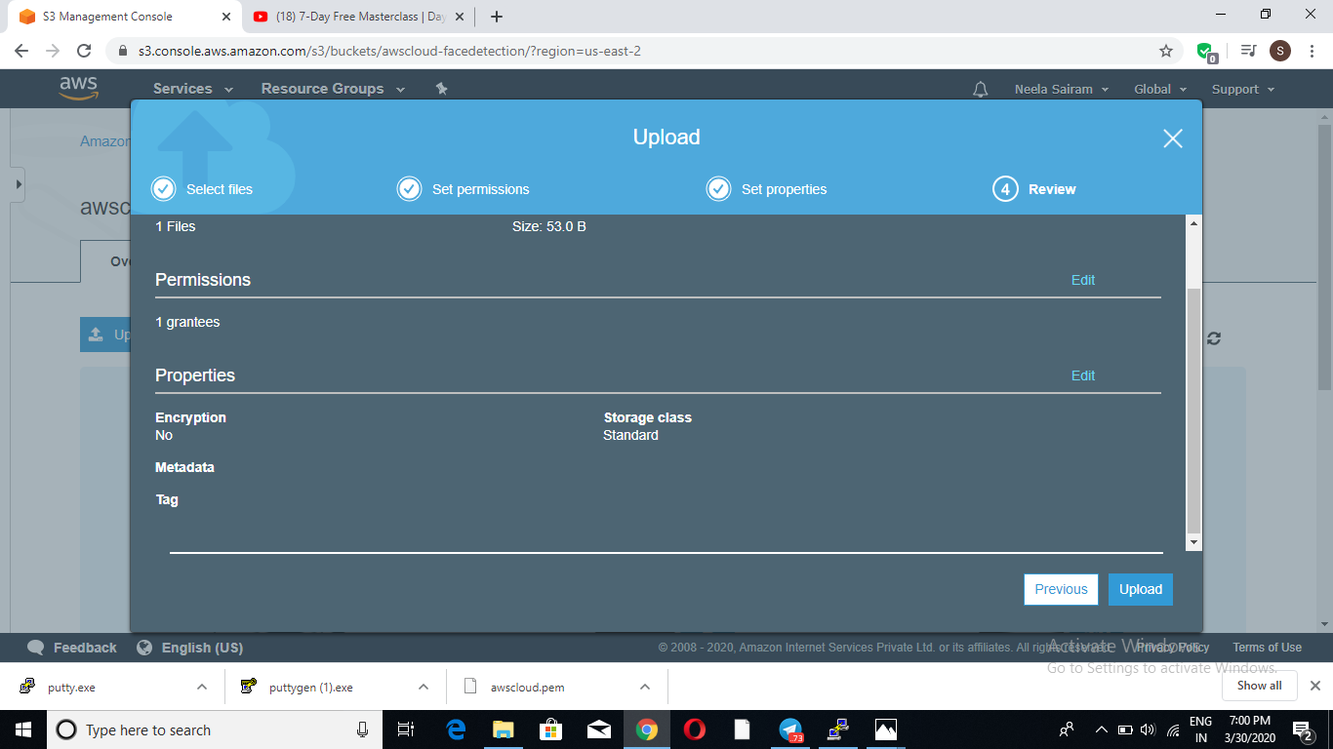

1. **Enabling Static Website:**

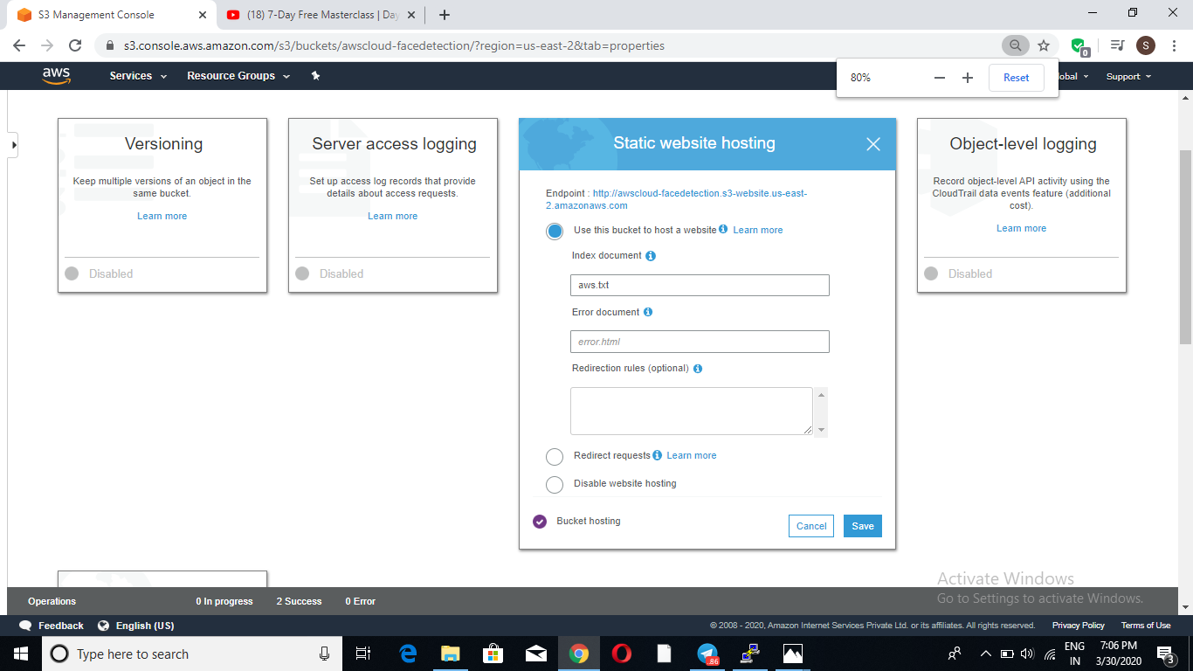

1. **Making the Object Public:**

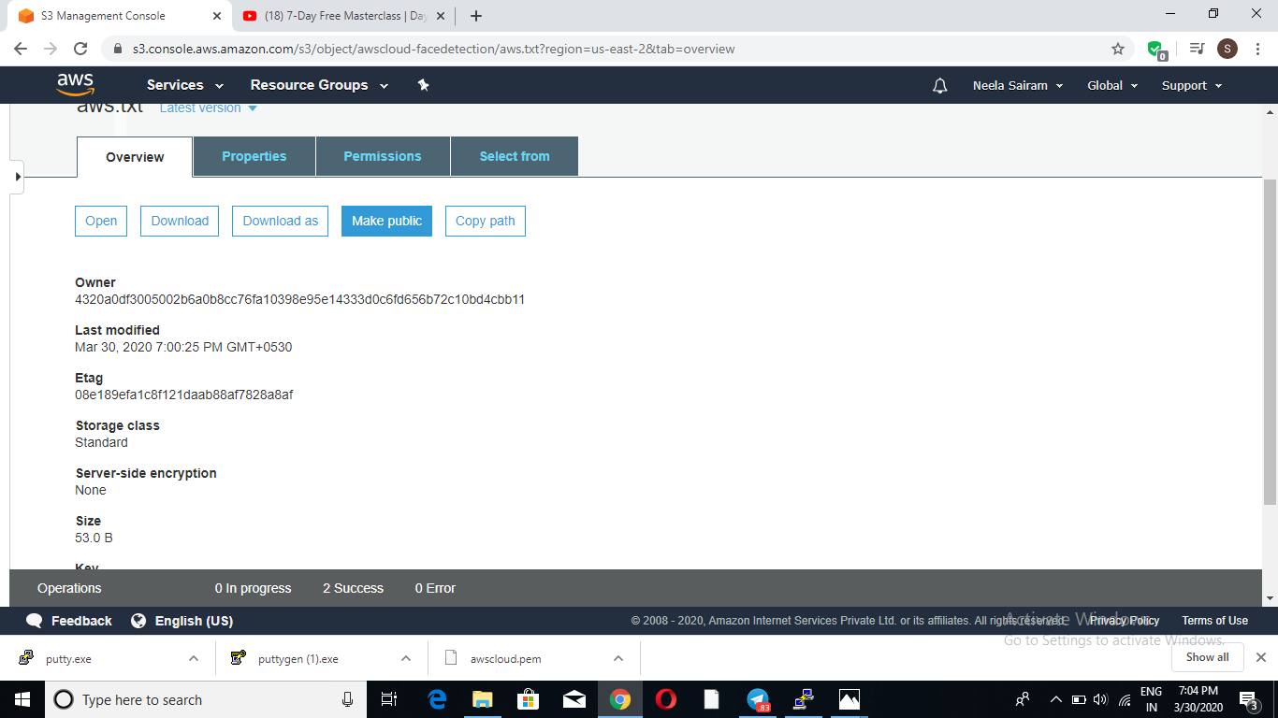

1. **Checking the S3 link on the browser:**



**Rekognition:**

1. **Face Detect:**

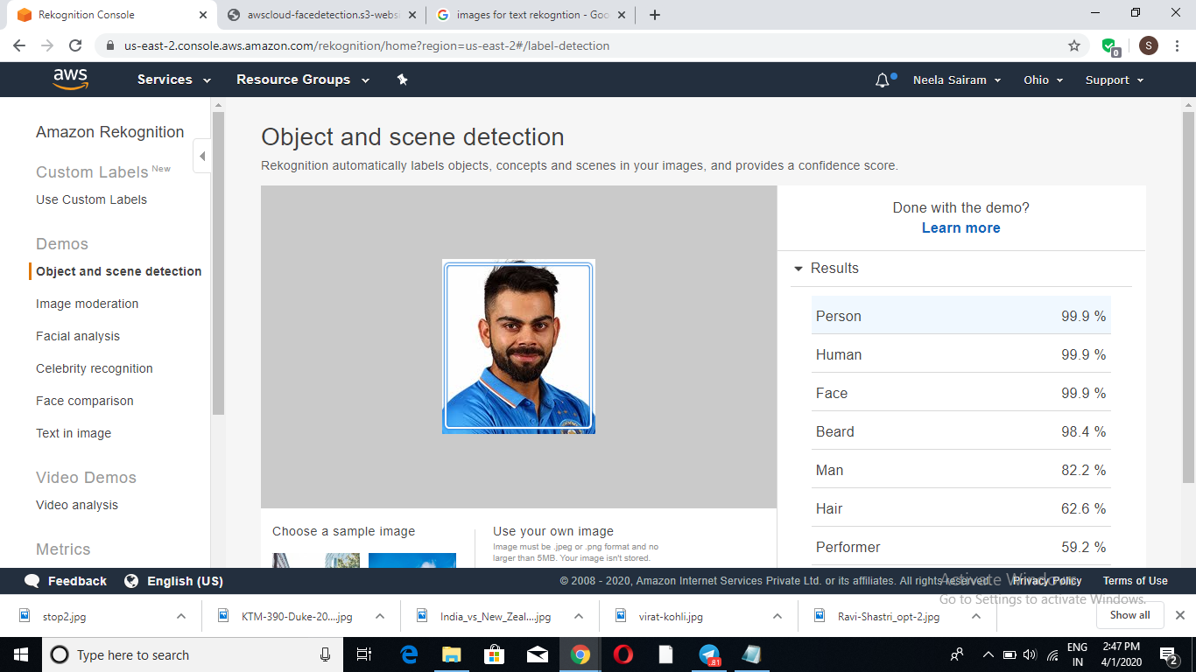

1. **Face Compare:**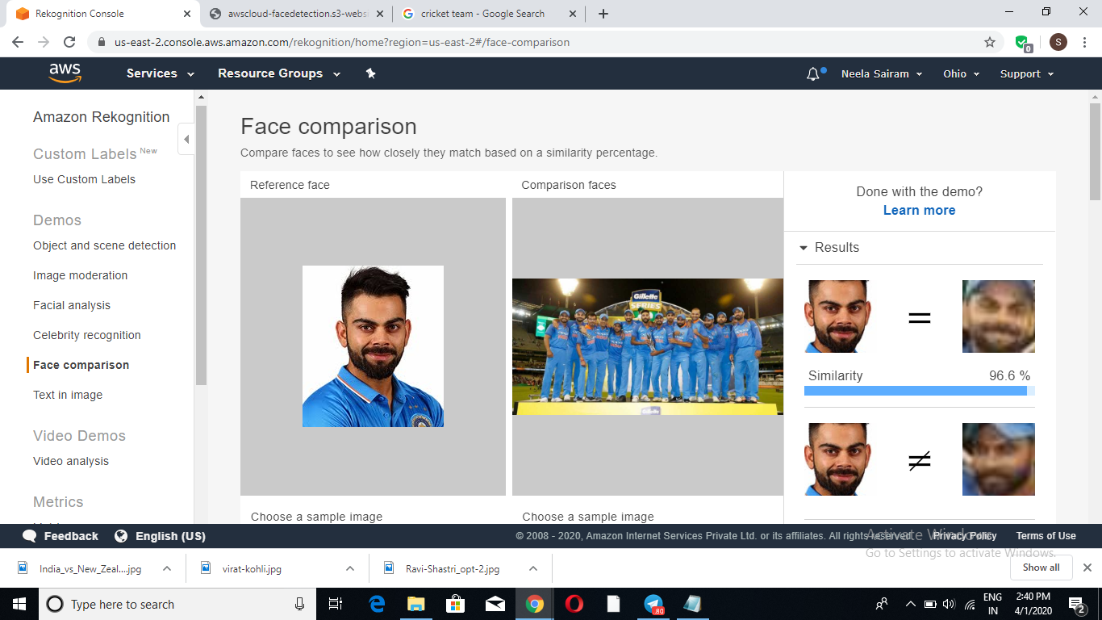
2. **Celebrity Recognition:**

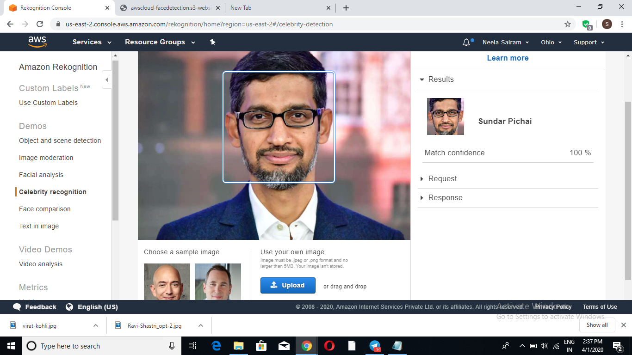

1. **Text in Image:**

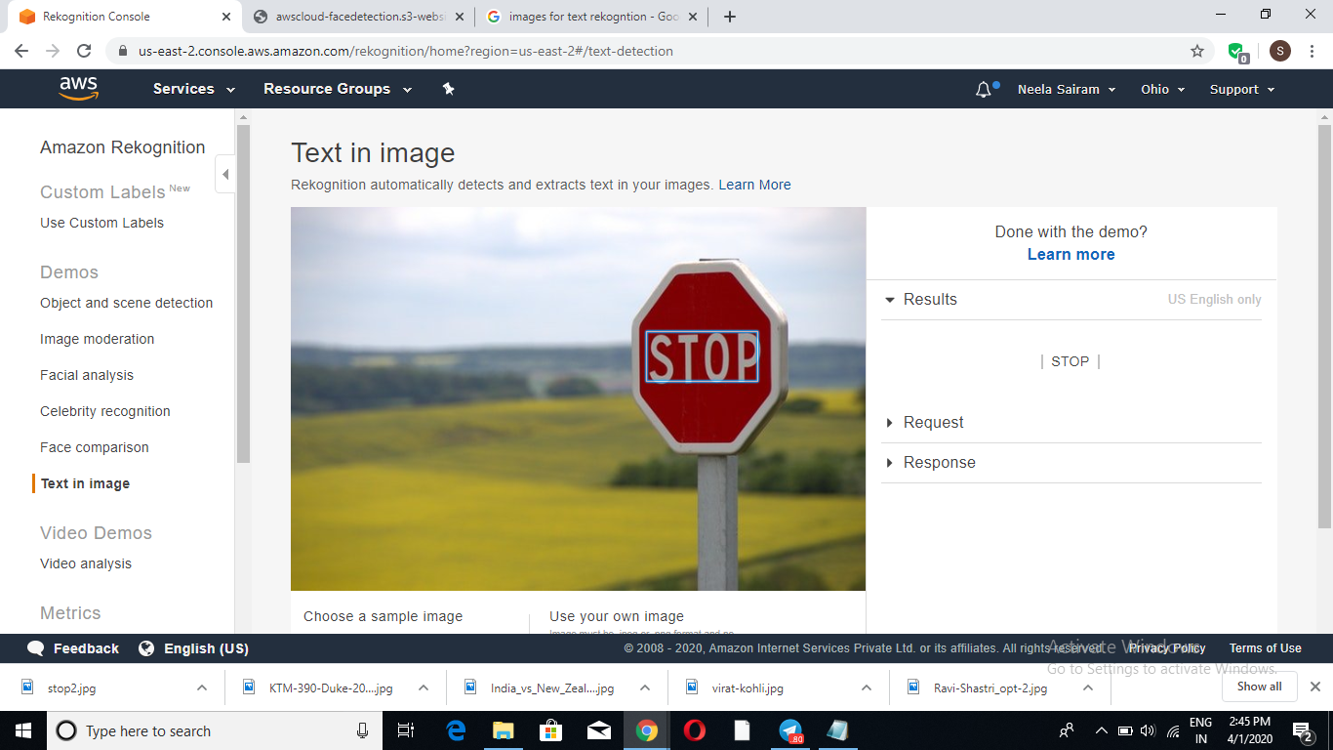

**EC2 & S3:**

1. **Installing aws-sdk:**

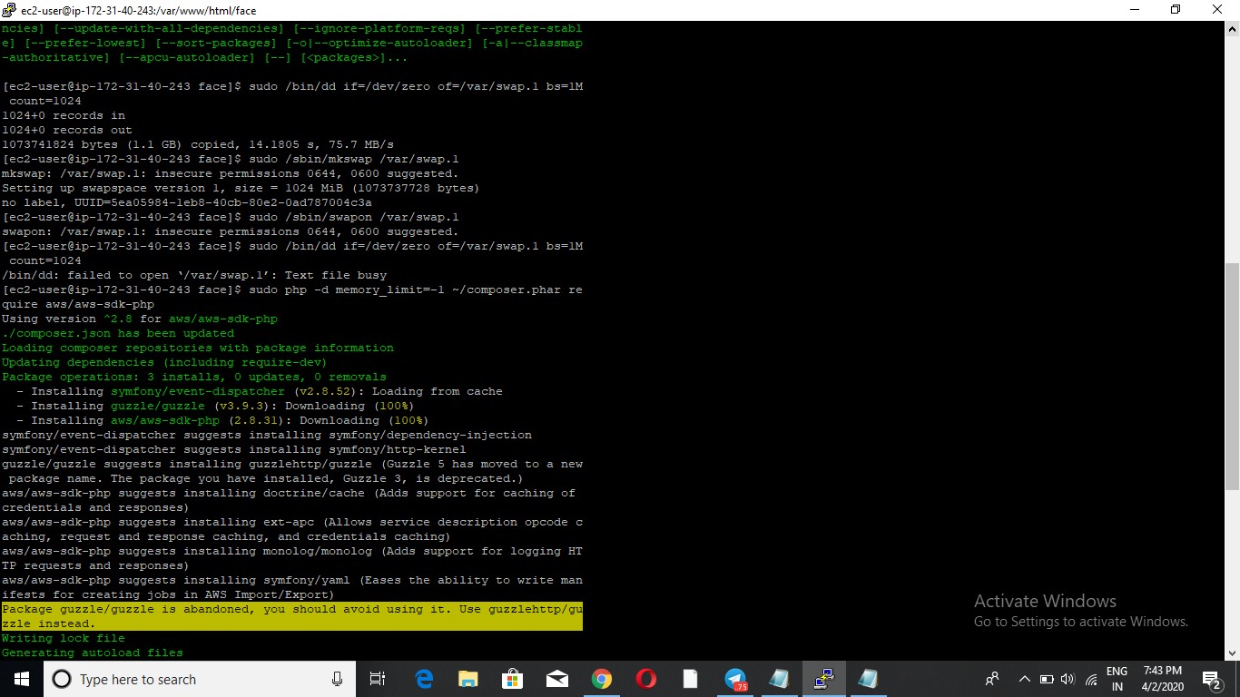

1. **Installing php:**

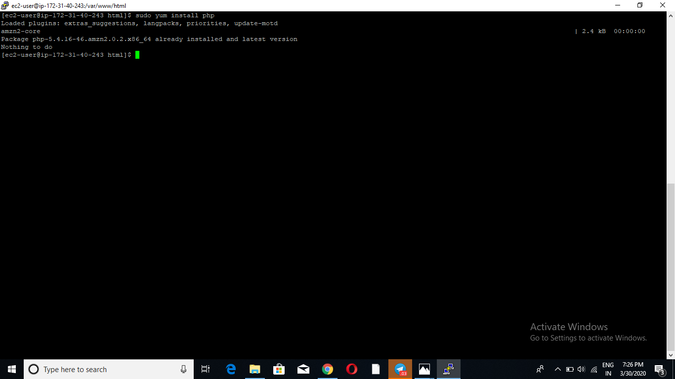

1. **Index.php file code:**

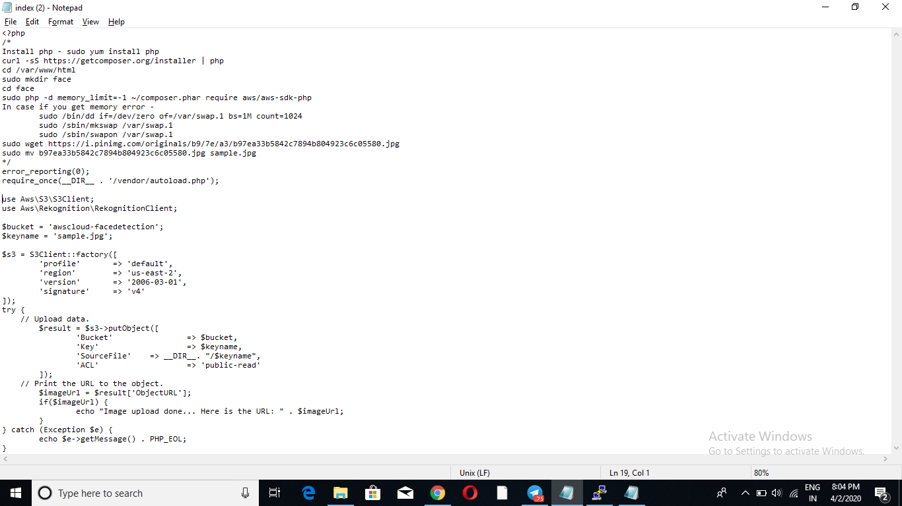

1. **Upload success:**

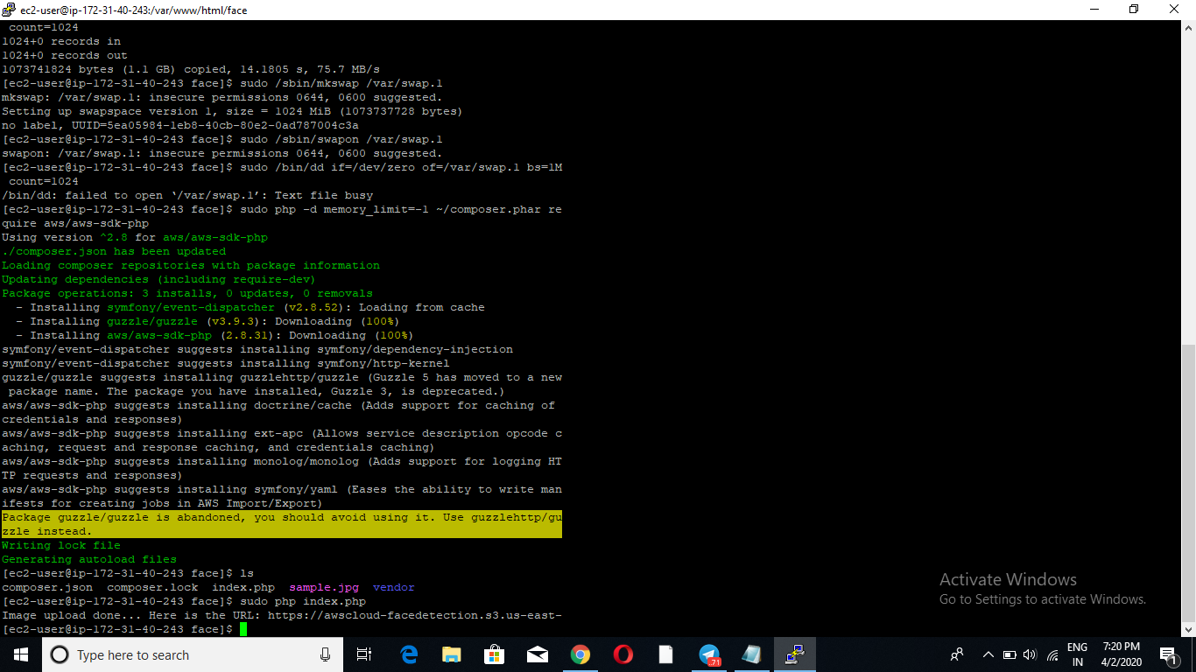

**EC2 & Rekognition:**

1. **Face Detect success:**

